Chapter 1 Problem 22 Michael Streyle

##   
## Call:  
## lm(formula = hardness ~ hours)  
##   
## Coefficients:  
## (Intercept) hours   
## 168.600 2.034

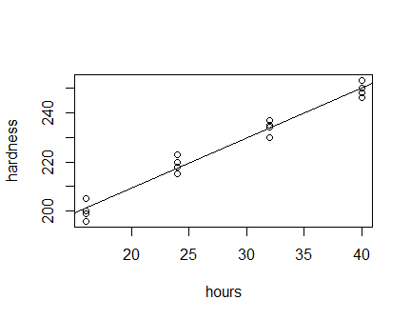

## (Intercept)   
## 249.975

## (Intercept)   
## 252.0094

## (Intercept)   
## 2.034375

The intercept is 168.6 Hardness units and the slope is 2.0344 hardness units per hour.

Written Out Answers to Question 22

1. The estimated regression function is Ŷ = 168.6 + 2.0344(X). The regression line does seem to have a good fit for the data – it follows the data points well.
2. A point estimate of the mean hardness when X = 40 hours is 249.975.
3. The point estimate of the mean hardness when X = 41 hours is 252.0094. The difference between when X = 40 and when X = 41 is 2.034375.